Strategic Product Placement Analysis Using Tableau
Team Member Name:
1.Shivam Rai(202401100200289)
2.Pranjal Mishra(202401100200230)
3.Sanya Rai(202401100200274)
4.Prathmesh Singh(202401100200235)
1. Introduction
In today’s competitive retail environment, product placement plays a critical role in influencing customer purchasing behaviour. Businesses strategically position products in various store locations such as checkout counters, shelves, and promotional areas to maximize visibility and boost sales.
With the help of data visualization tools like Tableau, organizations can transform raw data into meaningful insights. Tableau enables the creation of interactive dashboards that help identify sales patterns, customer preferences, and the effectiveness of different placement strategies.
This project focuses on analysing how product positioning impacts sales performance and consumer behaviour, enabling businesses to make data-driven decisions.

2. Problem Statement
Retail businesses often invest heavily in marketing and product display strategies, but they face challenges such as:
- Identifying which placement generates maximum sales
- Understanding customer behaviour across store areas
- Evaluating the impact of demographics on purchasing
👉 Core Problem:
Determining the most effective product placement strategy to maximize revenue.

3. Objectives of the Project
The main objectives of this project are:
- Analysis the relationship between product placement and sales
- Visualize sales trends using interactive dashboards
- Identify high-performing placement locations
- Understand customer demographics and behaviour
- Provide actionable business recommendations

4. Dataset Description
The dataset contains retail data including:
📌 Key Fields:
- Product Category
- Product Position
- Sales Volume
- Price
- Competitor Price
- Foot Traffic
- Promotion
- Consumer Demographics

5. Data Preparation
Before visualization, the dataset was cleaned and processed:
✔ Steps:
- Removed missing values and duplicates
- Standardized categories
- Converted numeric fields (Sales, Price)
- Structured data into Dimensions & Measures
📊 Dimensions:
- Product Category
- Product Position
- Consumer Demographics
- Promotion
- Foot Traffic
📈 Measures:
- Sales Volume
- Price
- Competitor Price

6. Data Visualization
Using Tableau, multiple charts were created:
📊 1. Avg Sales Volume by Product Category
- Type: Pie Chart
- Insight: Category contribution to total sales
📊 2. Avg Sales Volume by Product Category (Bar)
- Type: Bar Chart
- Insight: Compare category performance
📊 3. Consumer Demographics vs Sales Volume
- Type: Donut Chart
- Insight: Sales contribution by customer groups
📊 4. Foot Traffic vs Sales Volume
- Type: Bar Chart
- Insight: Impact of store traffic on sales
📊 5. Competitor Price vs Price
- Type: Scatter Plot
- Insight: Pricing strategy comparison
📊 6. Promotion Impact
- Type: Stacked Bar Chart
- Insight: Effect of promotions on sales
📊 7. Product Category vs Price
- Type: Bar Chart
- Insight: Pricing distribution across categories
📊 8. Product Position vs Sales
- Type: Stacked Bar Chart
- Insight: Best product placement locations

7. Dashboard Design
An interactive dashboard was developed with:
🎛 Filters:
- Product Category
- Product Position
- Promotion
- Foot Traffic
🧩 Layout:
- Top → Category Analysis
- Middle → Pricing & Demographics
- Bottom → Placement & Promotions
👉 The dashboard provides a complete business overview.
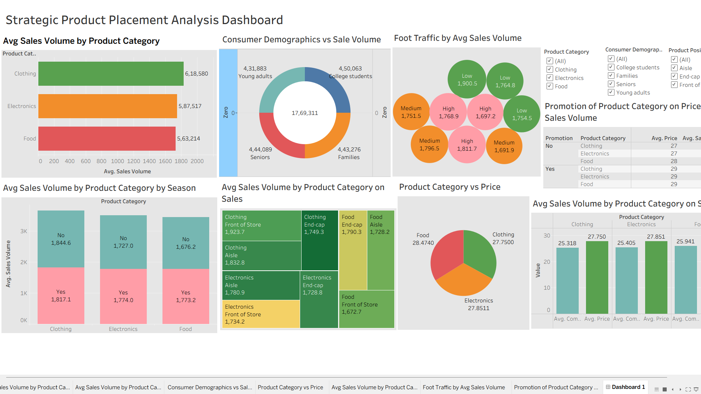

8. Story Creation
The Story feature in Tableau was used to present insights step by step.

📖 Story Scene 1 – Introduction
Overview of the dataset and business problem.
This scene explains the importance of product placement and defines the objective of improving sales using data analysis.

📖 Story Scene 2 – Sales Trends
Analysis of sales patterns across different product categories.
This scene highlights high-performing categories and shows how sales vary based on different conditions.

📖 Story Scene 3 – Placement Strategy
Comparison of sales performance across different product positions.
It shows how placements like front display and eye-level shelves impact sales.

📖 Story Scene 4 – Customer Behaviour
Insights into demographic purchasing patterns.
This scene analysis how different consumer groups contribute to sales and their preferences.

📖 Story Scene 5 – Final Insights
Key recommendations for improving product placement.
It summarizes findings and suggests strategies such as better placement, targeted promotions, and pricing optimization.

9. Performance Testing
Performance testing ensures that the dashboard operates efficiently and provides a smooth user experience while interacting with data.

🎛 Data Filters Used
The following interactive filters were implemented to allow dynamic data exploration:
- Category Filter
- Placement Location Filter
- Date Filter
- Age Group Filter
👉 These filters help users analysis specific segments of data quickly and improve dashboard usability.

🧮 Calculated Fields Used
The following calculated fields were created in Tableau to enhance analysis:
- Total Sales
SUM([Revenue])
- Average Sales
AVG([Revenue])
- Revenue per Unit
SUM([Revenue]) / SUM([Units_Sold])
👉 These calculations provide deeper insights into sales performance and efficiency.

📊 Visualizations Used
The project includes the following components:
- 6 Charts (Pie, Bar, Scatter, Stacked Bar, etc.)
- 1 Interactive Dashboard
- 1 Story with 5 Scenes
👉 These visual elements collectively provide a comprehensive view of product placement analysis.

10. Web Integration Using Flask
To make the project interactive and accessible, it was deployed using Flask + Bootstrap UI.
🔹 Steps:
- Publish dashboard on Tableau Public
- Copy embed code
- Integrate into HTML using Bootstrap
- Serve using Flask backend
🔹 Flask Code:
from flask import Flask, render_template

app = Flask(__name__)

@app.route("/")
def home():
return render_template("index.html")

if __name__ == "__main__":
app.run(debug=True)

This allows users to interact with the dashboard through a web browser.

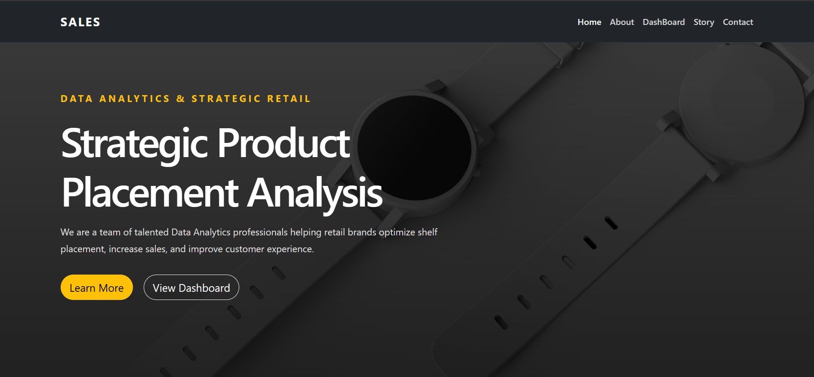

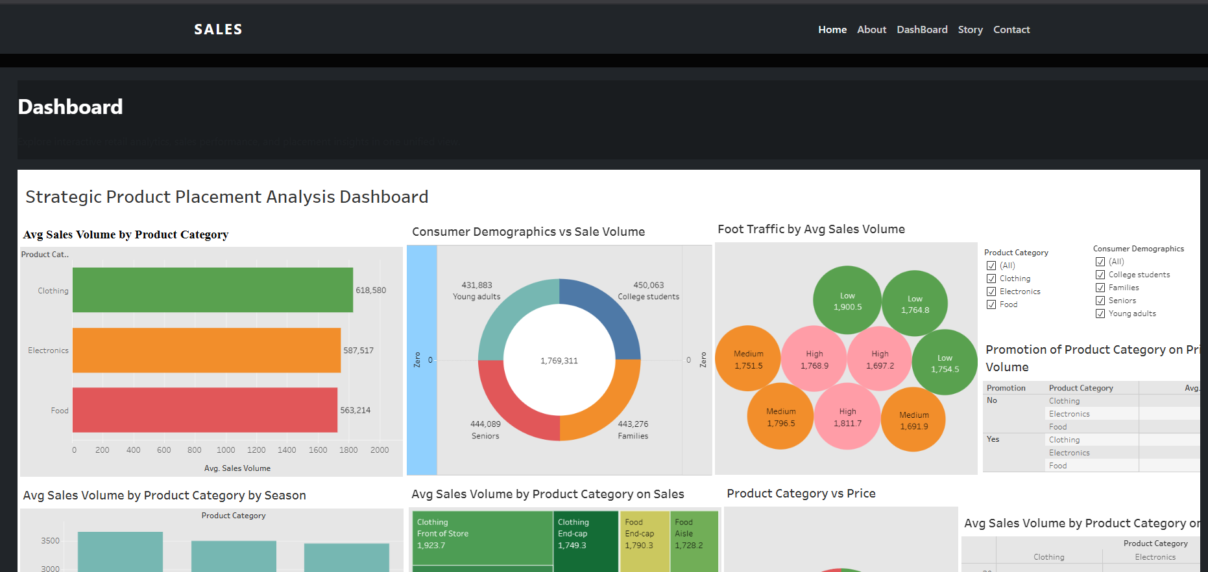

11. Results and Insights
From the analysis:
- High foot traffic significantly increases sales
- Promotions boost product visibility and revenue
- Competitive pricing influences customer decisions
- Certain product categories dominate sales
- Strategic placement (front/eye-level) improves performance

12. Conclusion
This project successfully demonstrates how Tableau dashboards combined with Flask web integration can provide powerful business insights.
✔ Key Learnings:
- Data visualization improves decision-making
- Product placement directly impacts sales
- Customer behaviour analysis helps targeting
- Full-stack integration enhances project value
👉 This project highlights the importance of data-driven retail strategies.

GitHub Repository link: https://github.com/raishivam-24/product-placement-analysis

